COMPUTE SMONTH = XDATE.MONTH(saledate).  COMPUTE SYEAR = XDATE.YEAR(saledate).  CROSSTABS SMONTH BY SYEAR.  COMPUTE MONTHS=0.  IF (SYEAR=2022) MONTHS = SMONTH - 5.  IF (SYEAR=2023) MONTHS = SMONTH + 7.  IF (SYEAR=2024) MONTHS = SMONTH + 19.  CROSSTABS MONTHS BY SYEAR.  FREQ MONTHS.  * Create time series based on average properties.  RECODE SCOND (4=1)(ELSE=0) INTO AVERAGE.  FILTER BY AVERAGE.  FREQUENCIES AVERAGE.  COMPUTE SPPSF=(saleprice/sRESB_FLOORAREA).  GRAPH/SCATTER=MONTHS WITH SPPSF.  MEANS SPPSF BY MONTHS/CELLS=COUNT MEDIAN MEAN.  * LOOK AT THE SCATTERPLOT AND FIT A LOESS LINE TO DETERMINE THE MONTHS WHERE  THE SLOPE OF THE TIME LINE CHANGED.  *DEFINE SPLINE VARIABLES TO CAPTURE THE TIME PERIODS.  COMPUTE MONTHS_1TO9=MONTHS.  IF (MONTHS>9) MONTHS_1TO9=9.  COMPUTE MONTHS_10TO16=0.  IF (MONTHS>9) MONTHS_10TO16=MONTHS-9.  IF (MONTHS>16) MONTHS_10TO16=7.  COMPUTE MONTHS_17TO24=0.  IF (MONTHS>16) MONTHS_17TO24=MONTHS-16.  MEANS MONTHS_1TO9 MONTHS_10TO16 MONTHS_17TO24 BY MONTHS/CELLS=MEAN.  COMPUTE LN_SPPSF=LN(SPPSF).  REGRESSION  /DEPENDENT=LN_SPPSF  /METHOD=BACKWARD  ARTERIAL  SINGLE_FAMILY1STORY TO HALF_DUPLEX2STORY  SMALLEST TO LARGEST  TWO_PLUS_BATHS TO POWDER_ROOM  GOOD TO VERY_POOR_UNSOUND  QABOVE_AVG TO QBELOW_AVG  YB_PRE_1929 TO YB_POST_1961  CRAWL SLAB  LN_GARAGESPACES FIREPLACE  HOT_WATER TO CENTRAL_AIR  MONTHS_1TO9 MONTHS_10TO16 MONTHS_17TO24.  *COPY REGRESSION COEF INTO THE RATES FOR TIME VARIABLES.  COMPUTE RATE1 =0.  COMPUTE RATE2 =0.003296.  * COMPUTE RATE3 =0.  * MAKE SURE YOU UPDATE TIME VARIABLES.  COMPUTE PRICE_INDEX = (1+RATE1)**MONTHS_1TO9* (1+RATE2)**MONTHS_10TO16* (1+RATE3)**MONTHS_17TO24.  GRAPH/SCATTER=MONTHS WITH PRICE_INDEX.  *TIME ADJUSTMENT FACTORS.  MEANS PRICE_INDEX BY MONTHS/CELLS=MEAN.  *RECORD THE VALUE FOR LAST MONTH (TARGET MONTH) AS END_INDEX.  *DON'T FORGET TO UPDATE END_INDEX!!!.  COMPUTE END_INDEX=1.0541.  COMPUTE TAF=END_INDEX/PRICE_INDEX.  GRAPH/SCATTER=MONTHS WITH TAF.  MEANS TAF BY MONTHS/CELLS=MEAN.  COMPUTE TASP=saleprice*TAF.  COMPUTE TASPPSF=TASP/sRESB_FLOORAREA.  DES saleprice TASP TAF TASPPSF.  FILTER OFF. | - Create month numbers, setting the first month in the sales period to 1, and the last to 24. Assign the values to a new field for each sale.  - Filter by average condition (not sure if we’re doing this in R)  - Calculate SPPSF  - Scatter plot – Months x SPPSF with Loess fit line  - Identify months where slope of fit line changes  - Create spline variables for each group of months (up to 3).  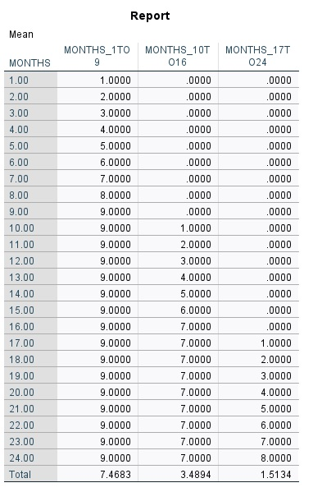  - Set values of spline variables to match the months. They should be 0 before they start, and the last number after they finish. For example, for MONTHS_10TO16, the value will be 0 from Months 1 through 9, the value will be 1-7 for Months 10-16, and the value will be 7 for Months 17-24.  - Calculate natural log of SPPSF  - Run regression with months variables to determine coefficients for rates.  - Copy coefficients from output for each variable. If any did not come out as significant, set to 0.  - Calculate Price Index  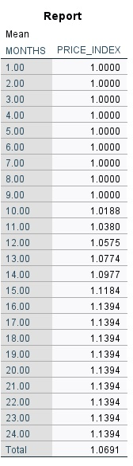  - Run Means by Price Index  - Copy value for last month into End Index variable.  - Calculate Time Adjustment Factor – End Index from #13 / Price Index.  - Calculate Time Adjusted Sale Price & Time Adjusted Sale Price Per Sqft  - Turn off filter of average condition properties

